**How to Calibrate a PID Line Following Robot**

By Scott Lawson 34359117 and Liam Hodgson 29154119

# INTRODUCTION

A well-tuned PID algorithm is essential to the successful operation of a line following robot. Line following PID algorithms use differential and integral calculus to ensure that the robot accurately follows a line and automatically adjusts to changes in line direction. These instructions are intended for Engineering Physics students who have completed their first year of engineering studies and have a basic understanding of microprocessors. The behaviour of the line following robot can be changed by modifying the PID algorithm settings. The major steps for PID tuning are: turning on the line following robot, modifying PID settings, optimizing sensor placement, and testing the robot.

# STEP-BY-STEP PROCEDURE

The basic steps for performing PID algorithm calibration are as follows:

## Turning on the Line Following Robot

Turn on the robot by connecting the 18.5V lithium-polymer battery in the battery connector and pressing the power switch (Figure 1). The robot will take several seconds to boot. The tape follower is ready to tune once the booting process is complete.

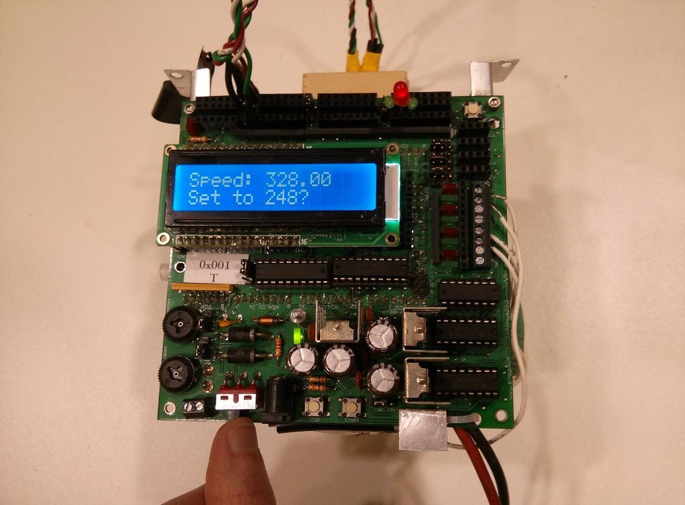

Figure 1. The power switch is located on the bottom left of the TINAH board.

**Warning:** Components of the TINAH board can reach high temperatures capable of causing skin burns. Care should be taken when handling the board; lightly touch a component first before grabbing hold of it.

## 2.2 Modifying the tuning parameters

### 2.2.1 Accessing the settings menu

Once the robot has been turned on, several values will be displayed on the LCD screen. Each value is a tuning parameter that can be changed to alter the behaviour of PID algorithm. The LCD screen will show one value at a time. To change the displayed value, rotate the upper knob found on the bottom left of the robot. Rotating the knob will scroll through a list of available tuning parameters.

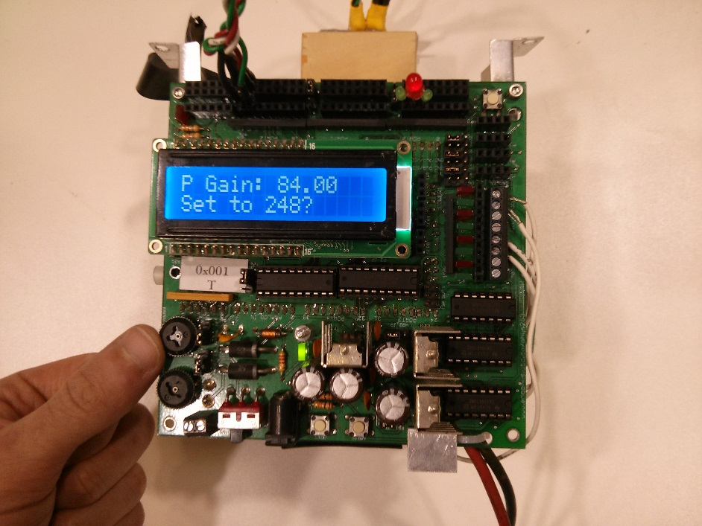

Figure 2. The upper left knob allows the user to scroll through a series of tuning parameters.

### 2.2.1 Modifying a setting

The value of each setting can be changed by rotating the lower knob, found on the bottom left of the TINAH board (Figure 3). The setting must be a number between 0 and 255. 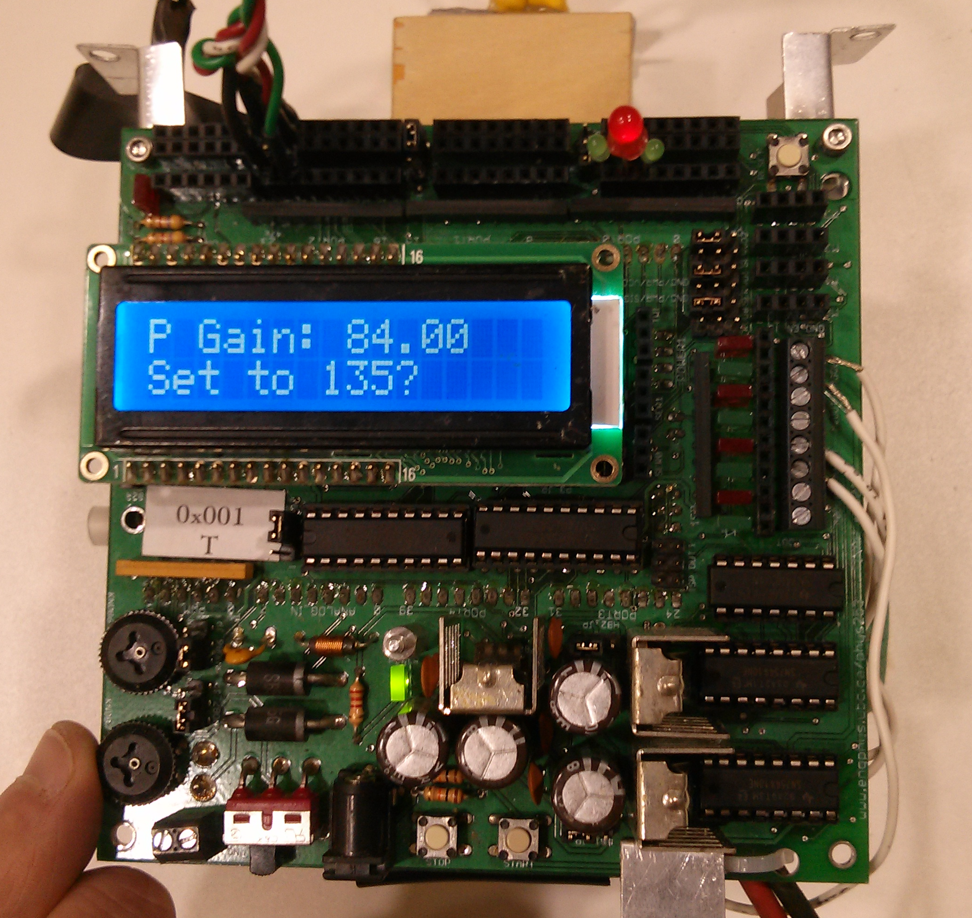

Figure 3. Rotating the lower knob will adjust the value of the displayed tuning parameter.

### 2.2.3 Confirming a setting change

To confirm a setting value change, press the button labelled STOP found on the bottom left of the TINAH board (Figure 4). This will save setting and the saved value will be restored when the robot is restarted.

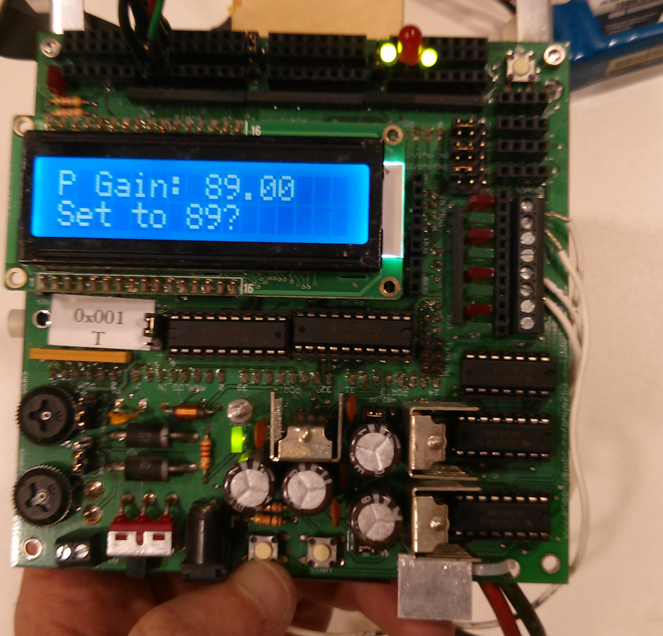

Figure 4. The bottom left button allows the user to confirm changes made to the tuning parameters.

### 2.2.4 Understanding the settings

* *P Gain* stands for *Proportional Gain.* Increasing this value will make the tape follower turn more sharply to compensate for veering off course. Decreasing this value will make the tape follower less sensitive to error.
* *D Gain* stands for *Derivative Gain*. Larger values of derivative gain will increase the rate at which the robot reacts to errors in tape following. A value too large will cause the robot to oscillate and navigate erratically.
* *Speed* represents the overall speed of the tape follower. Large speed values may be unstable and the tape follower may be too slow to react to error.
* *Thresh* stands for *Threshold* and this represents the threshold amount of reflected light that the robot should consider to be tape. If this value is too low, everything will be considered tape. If it is too high, then nothing will be considered tape and the robot will be unable to navigate. It is good practice to set the threshold 5 units higher than the ambient white floor.

## 2.3 Optimizing the sensor placement

Sensor placement is very important. The most accurate tape measurements occur when the sensors are placed a short distance from the ground. It is good practice to ensure that the light sensors are no more than 3 mm from the ground. The sensor location can be adjusted by bending the metal bracket that holds the sensors. The sensor bracket and light sensors can be seen in Figure 5.

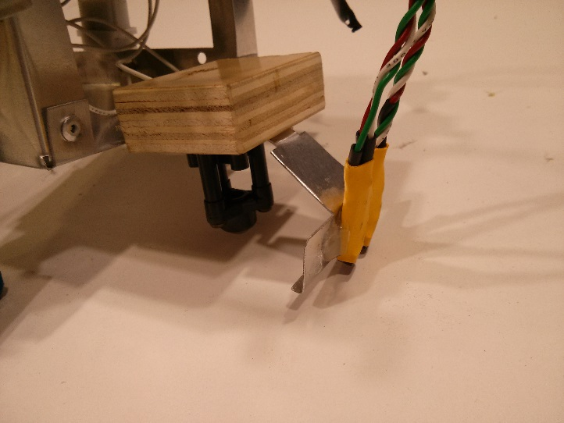

Figure 5. The metal sensor bracket can be bent and deformed to allow the sensors to be placed closer to the ground.

## 2.4 Testing the line following robot

When the values have been tuned correctly, press the button on the bottom right of the robot. This will initiate navigation and the robot will begin to move. Place the robot on the line with the sensors directly over the line. Figure 6 shows the location of the button. The navigation screen displays the raw infrared sensor values in the top line and the motor speed values in the bottom line. L and R indicate the left and right sensors respectively.

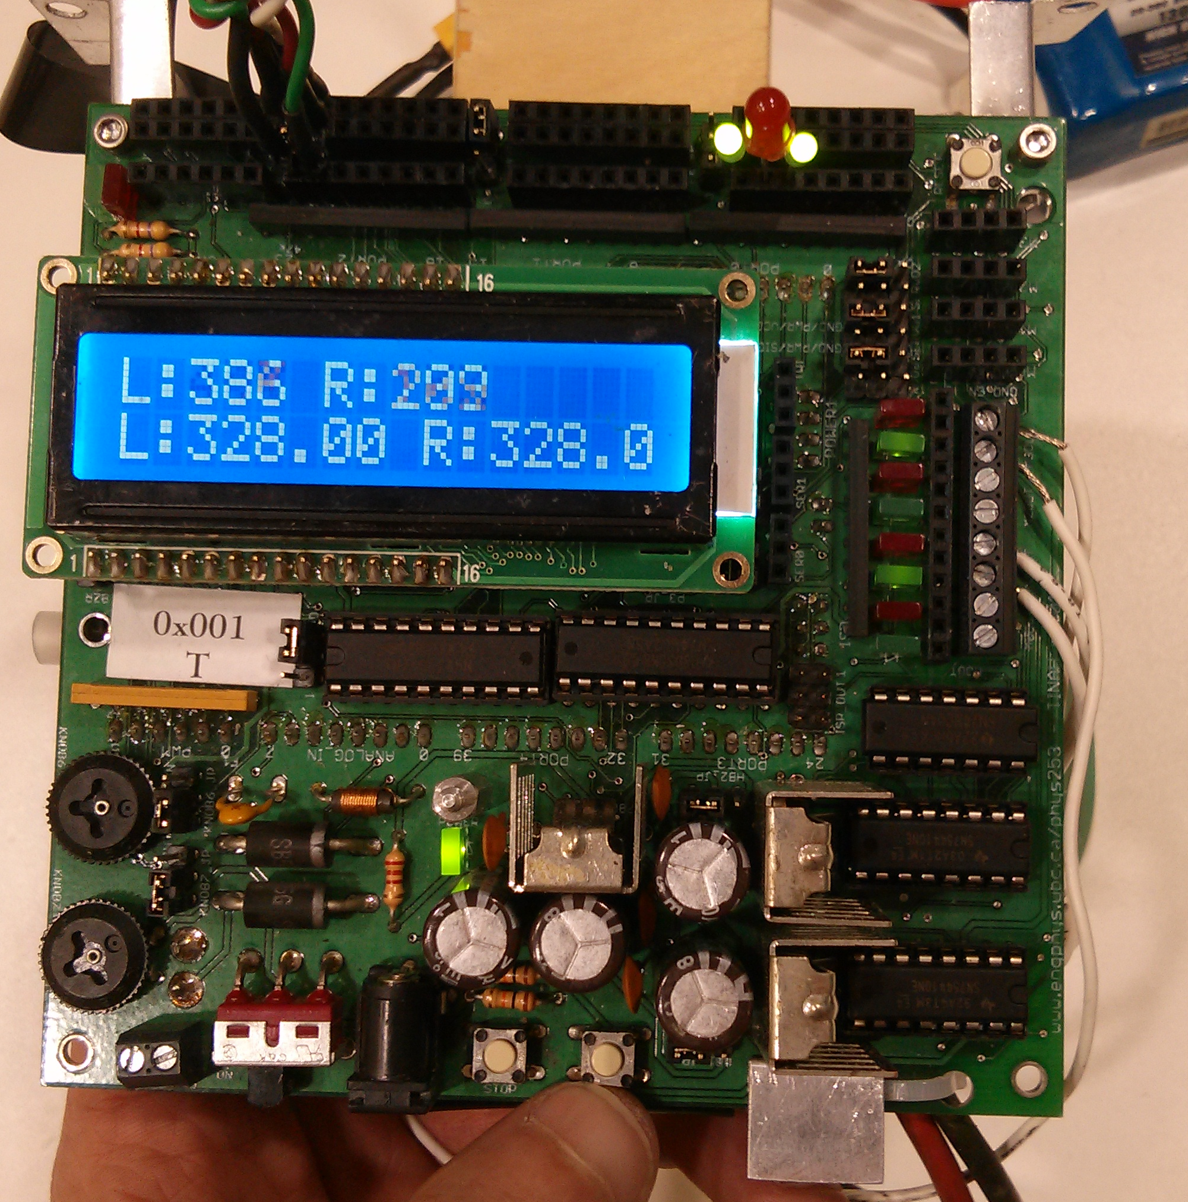

Figure 6. The bottom right button will confirm the settings and initialize the tape following sequence.

# Note: Handle the wires and electronic components carefully, as they can break easily. If a component does break, remove it and replace it with a new part. Dispose of the broken component in the appropriate manner.

# CONCLUSION

Tuning the robot is a crucial part of the success of the line following robot. It allows the robot to navigate on the play surface and avoid obstacles. Proper calibration of the PID algorithm can dramatically improve performance of the robot. The main steps are modifying the tuning parameters, optimizing the sensor placement and testing. It is also important to place the sensors in the right location, as they provide the navigation data to the robot.

It is important to follow standard safety protocol when dealing with electronics to prevent burns. Electronic components can fail unexpectedly, so it is important to have replacement parts on hand.